5.5 Rectangles  
*2 points per problem*

*HIJK* is a rectangle. Draw *HIJK* and label the diagram with the given lengths. Find the value of *x* and the length of each diagonal.

**1.** *HJ* = *x* and *IK* = 2*x* −7

**2.** *HJ* = 3*x* + 5 and *IK* = 5*x* −9

**3.** *HJ* = 3*x* + 7 and *IK* = 6*x* − 11

**4.** *HJ* = 19 + 2*x* and *IK* = 3*x* + 22

**5.** *HJ* = 4*x* and *IK* = 7*x* − 12

**6.** *HJ* = *x* +40 and *IK* = 5*x*

*Regents Problems! You must Label VERY carefully before solving!*

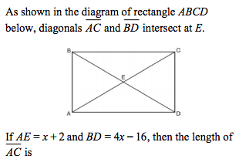7.

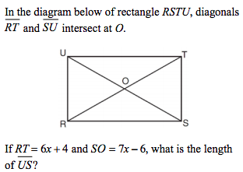8.

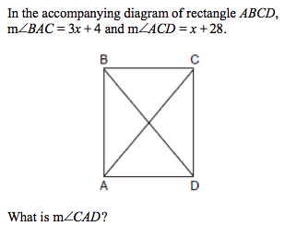9.

*Challenge*: Below is Rectangle *QRST*. Solve for x and y.

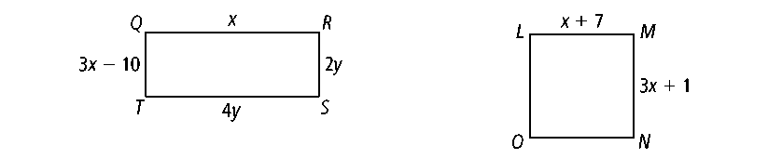

**Proof Extra Credit Problem (+5 HW points)**

**Given:** Rectangle *DVEO* with diagonals and 

**Prove:** ∆*OVE* ≅ ∆*DEV*